**How it Works:**

The Airvac can sort the lights and heavies of a material stream on a conveyor in 2 different ways:

1. **Vacuum Head**  
   The vacuum head (or vac head) is positioned over the material stream as shown in Fig. 1. It’s connected to the inlet of the Airvac via a hose. As the fan on the Airvac rotates, any light material passing under the vac head gets pulled up through it, getting sucked through the fan inlet and shot out of the outlet on the Airvac, where it can then be connected into a skip or area for collection, ultimately separating it from the heavy material on the conveyor.

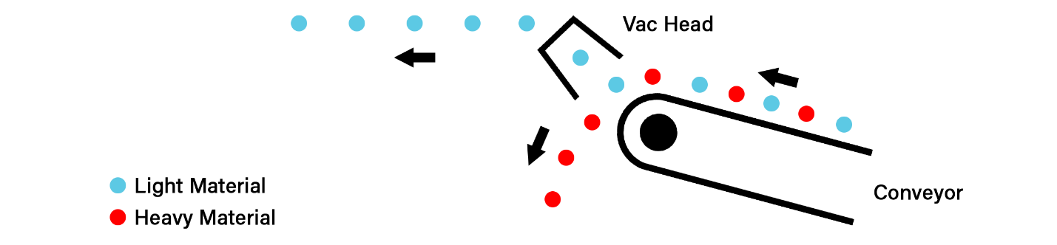

1. **Air-Knife**  
   The Air-knife is positioned as shown in Fig.2. It’s connected to the outlet of the Airvac via a hose. It has a large circular inlet and wide, narrow outlet. As the fan on the Airvac rotates, the airflow entering the air-knife is spread out along the narrow outlet, distributing it evenly across the width of the conveyor. As the air stream passes through the material coming off the belt, light material gets carried away and is blown out of the heavy material, thus separating the two.

